 | Monday | Tuesday | Wednesday | Thursday | Friday
April 20th - 24th | 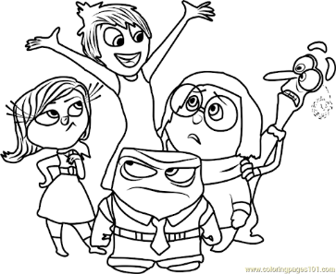  THINK AND DO MONDAY:  Think: Which emotion are you feeling right now? What can you do when you are feeling grumpy? What can you do when you are feeling sad?  Do: Make a list or draw a picture of three things that make you happy. | WRITE OR DRAW TUESDAY  Write a letter or draw a picture to your teacher or a staff member at Chandler Elementary.  Show Them!  Show Them - Snap a picture on the phone and send it to their email. | YOUTUBE WEDNESDAY:  Go to YouTube and listen to "Your Fantastic Elastic Brain" by JoAnn Deck.  Discussion Questions: 1.What does it mean to have a growth mindset? 2.What are 3 things your brain does that makes you, you? 3. The amygdala controls your emotions. Tell about 3 emotions you have experienced. 4. Why should we try again when we make mistakes? Think of a time you made a mistake but did not give up. | HELPING THURSDAY:  Do one chore today without being asked.  For example:  Make Your Bed  Wipe the Counters  Do the Dishes  Sweep the Floors | GRATITUDE AND FUN FRIDAY:  Build a fort out of blankets! Once you are done, sit inside the fort and tell someone ONE thing you are thankful for!

