Week Six | May 4th- 8th | THINK AND DO MONDAY  Think: What does it mean to be a good listener? Have you been a good listerner during the time at home?  Do: When an adult ask you to do something today, do it the first time and without complaining. | WRITE OR DRAW TUESDAY  Write a letter or draw a picture to someone who is elderly. It can be a grandparent, relative, friend, or someone you don't even know.  Mail It - Have an adult help you address the envelop and send it off. Don't forget the stamp!  The elderly have not been able to have contact with a lot of people and I am certain your letter will make them smile! | YOUTUBE WEDNESDAY  Go to YOUTUBE and listen to The Most Magnificent Thing by Ashley Spires.  https://www.youtube.com/watch?v=GgECc3gKuTo  Discussion Questions:  1. Tell a family member about something you have made or a skill you have tried to develop and how it made you feel when it didn't go the way you had planned.  2. What emotion did the main character feel after things didn't go as planned? What did she decide to do to help her calm down?  3. Share some things you have tried that help you calm down or release your feelings. | HELPING THURSDAY  Help out another kid (brother, sister, cousin, friend)  For example:  Help them with their chores  Teach them how to tie their shoes, if younger  Play with them | 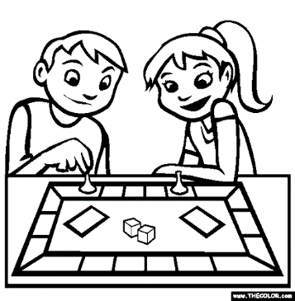  GRATITUDE AND FUN FRIDAY  Have a family game night. Tell your family ONE thing you are thankful for and ask them to do the same!

